Contents
1.0 Project Details 2
2.0 Project overview 2
3.0 Document objective 2
4.0 user login 3
5.0 Clock in & Clock out 3
5.1. Clock In 4
5.2. Clock Out 5

Project Details
Name | Human Resource Information System
Description | Design, develop and implement the HRIS for Universal Harvester Dairy Farms Inc..
Sponsor | Human Resource Department – TLCI & UHDFI
Project Manager | Mr. Mc Austine Philip M. Redondo
Project Team Resources | Mr. Allan O. Roxas  Mr. Austine M. Redondo  Mr. Mark Topher Villaluz  Mr. Lendie Catubig | Mr. Jaycee Pasia  Mr. Jimmy F. Felix  Mr. Ken Juvic Marasigan

2.0 Project overview
- Improve and enhance the timekeeping process of BMC, currently manual.
- Free the company from a subscription-based application.
- Allows the company for greater control over sensitive employee data, enhancing security measures that align with the organization’s policies and compliance requirements.

3.0 Document objective
- Improve and enhance the timekeeping process of BMC, currently manual.
- Free the company from a subscription-based application.

4.0 User Login
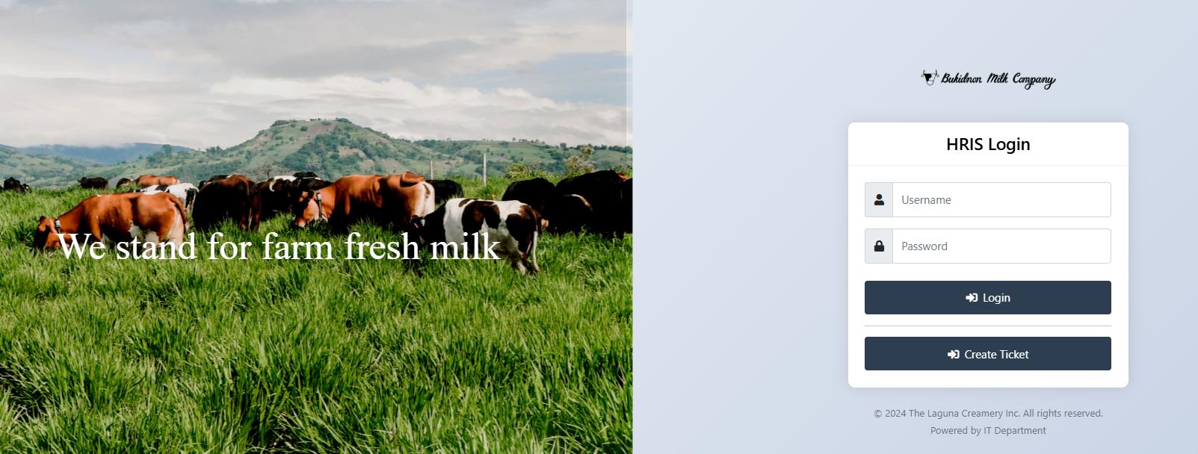
Image 1. Login Window
2
4
3
1

- Username: Input your correct username.
- Password: Input your correct password.
- Click login button to enter the system.
- This “Create Ticket” button redirects into a new page which is the ticketing system.
  - Once redirected, there is a new login page that will appear:
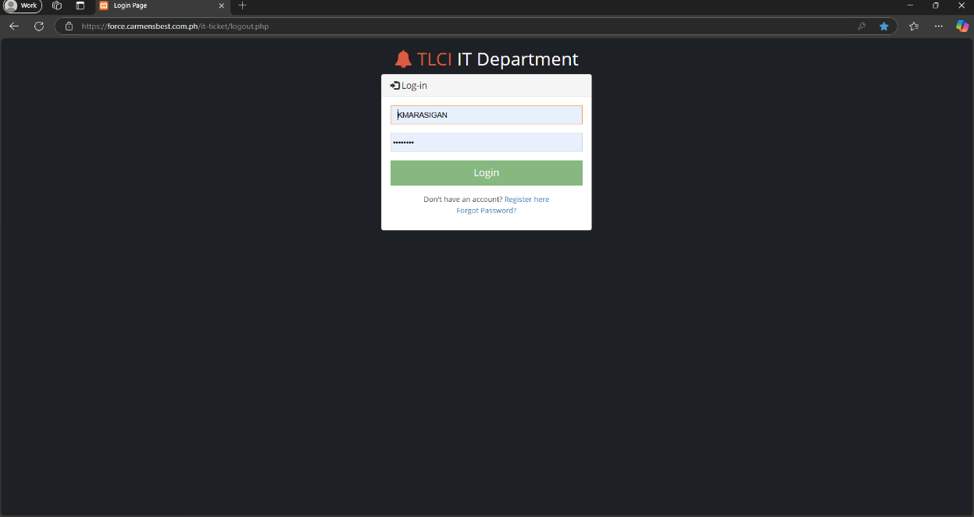
4.2
4.3
Image 2. Ticketing System
  - The login credentials are the same as the HRIS credentials. If the user does not have an account yet, we can register through the registration link.
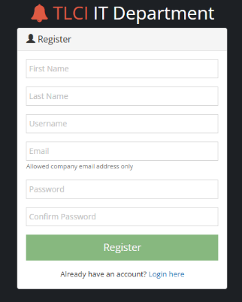
    - This is the registration page where we can fill up our details to register an account.

Image 3. Registration Page
Once you've filled out the fields with your credentials, click the 'Register' button to create your account and wait for the verification email to confirm that your account has been activated.
Fill out these fields and enter your information to register.

This message will appear if the email is already registered.
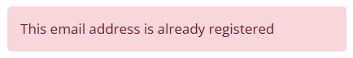

This message will appear if the email format is incorrect or if it is not a company email.
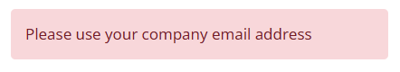

  - The “Forgot password?” link redirects into this reset password page.
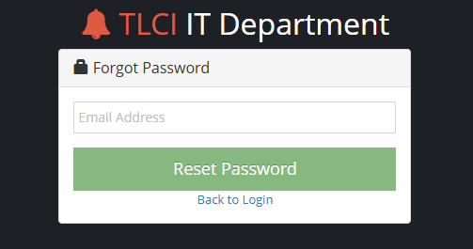
    - This is the 'Forgot Password' page, where you can enter your registered company email to receive password reset instructions.
Enter your company email address (the one that you registered), where the instructions to reset your password will be sent.

Once the company email is entered, click the 'Reset Password' button. Instructions to set a new password will be sent to your email.

Image 4. Password Reset Page
This message will appear if the instruction is already sent to email.
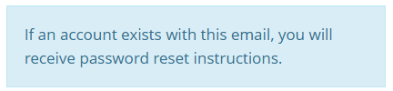

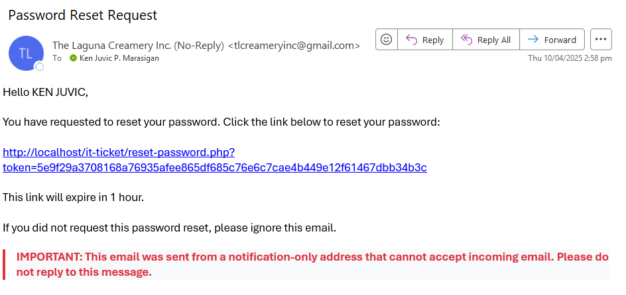
This is the email format you will receive upon submitting a password reset request. Just click the link to be redirected to the page to confirm your new password.

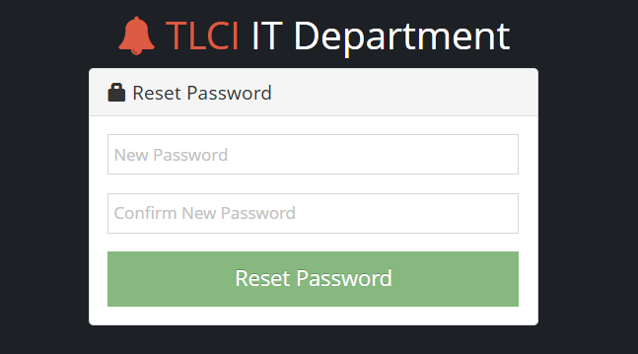

Enter your new password for “New Password” field, for “Confirm New Password” re-enter your new password for confirmation.
Click the “Reset Password” to confirm the newly changed password.

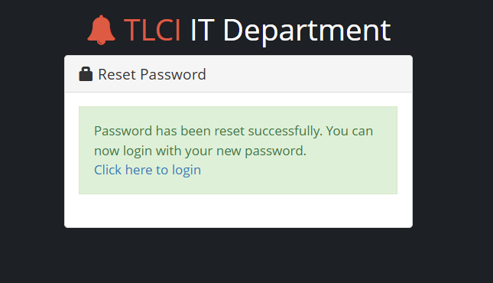
The “Click here to login” link redirects to login page.
This message will appear once the password has been successfully changed.

- Upon successful login, you will be redirected to the system dashboard.
Note: If you input the wrong username or password, you will not be able to login.

5.0 Dashboard

- Upon successful login, the dashboard will be the first screen to appear. This is what the dashboard looks like:
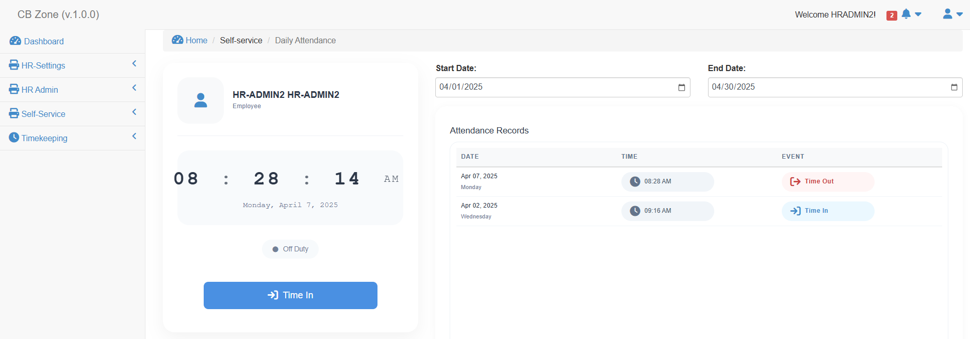

  - This is the side navigation, which provides quick access to the main sections and different factions within the dashboard.
  - This is the time indicator, where you can view the current date and time in real-time.
  - These are the Time In and Time Out buttons. The button changes its appearance when clicked—'Time In' appears in blue, and 'Time Out' appears in red
  - This is the date filter for the attendance records. It allows you to set the start and end dates, which determine the range of attendance records displayed.
  - This is the attendance record table, which displays the data where the 'Time In' and 'Time Out' entries are recorded.
  - This is the head navigation bar, displaying options such as 'User Profile', 'About', and 'Logout' for easy access to account-related features.

6.0 Clock in & Clock out
The 'Time In' button is used to start recording your attendance each day.
Image 2. Dashboard

Note: The “Time In” and “Time Out” button changes every time it is clicked.

Clock In


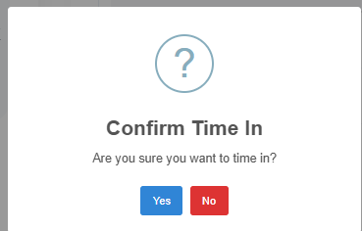


Once you click the 'Time In' button, a confirmation window will appear, as shown in the image below.
Click 'Yes' to confirm.
Click 'No' to cancel.

.

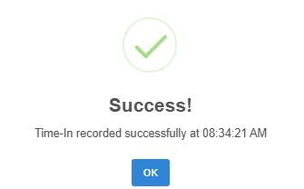
A success message will appear if the clock-in is successful. Click the 'OK' button to proceed.

Your clock-in time will be reflected in the attendance record table.

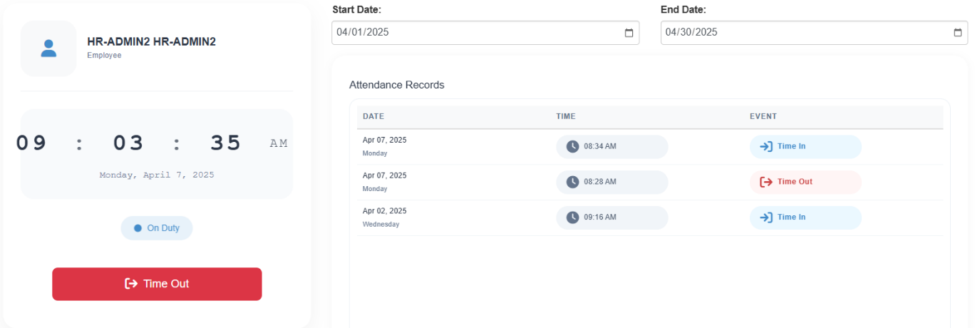

5.2. Clock Out
- Time out button is used to end your attendance every day.
1
- Once you click the time out button, a confirmation window will appear as shown on the image below.
Click yes to proceed.
Click no to cancel.
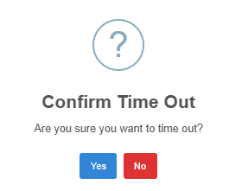

2

- A success window will appear if the clock out is successful. Then click ok button to proceed.
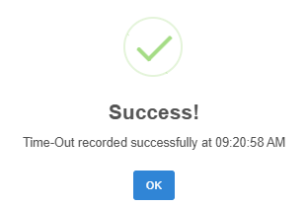

- The time out button will change to time in button after clock out.
- Your clock in will reflect on the attendance record table.
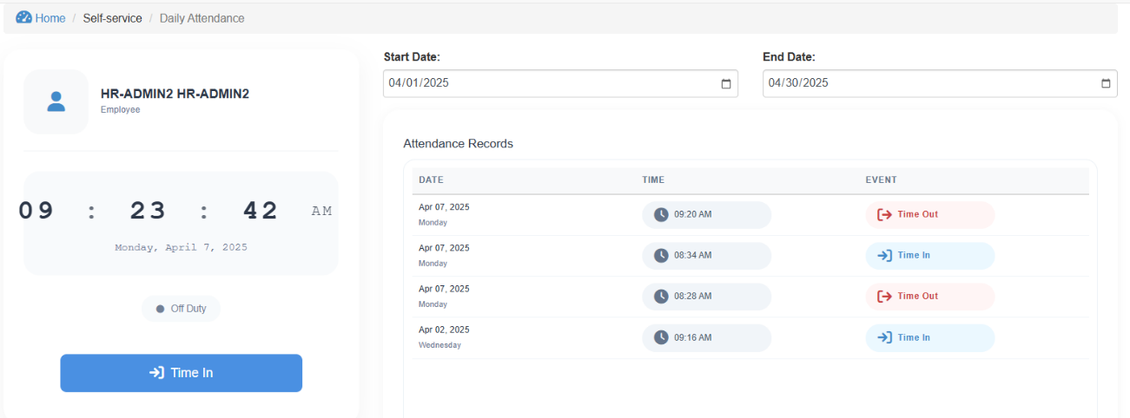

5

4

6.0 Self Service

6.1. Change Schedule
- Navigate the change schedule by clicking the Self-Service catalog in the navigation bar.
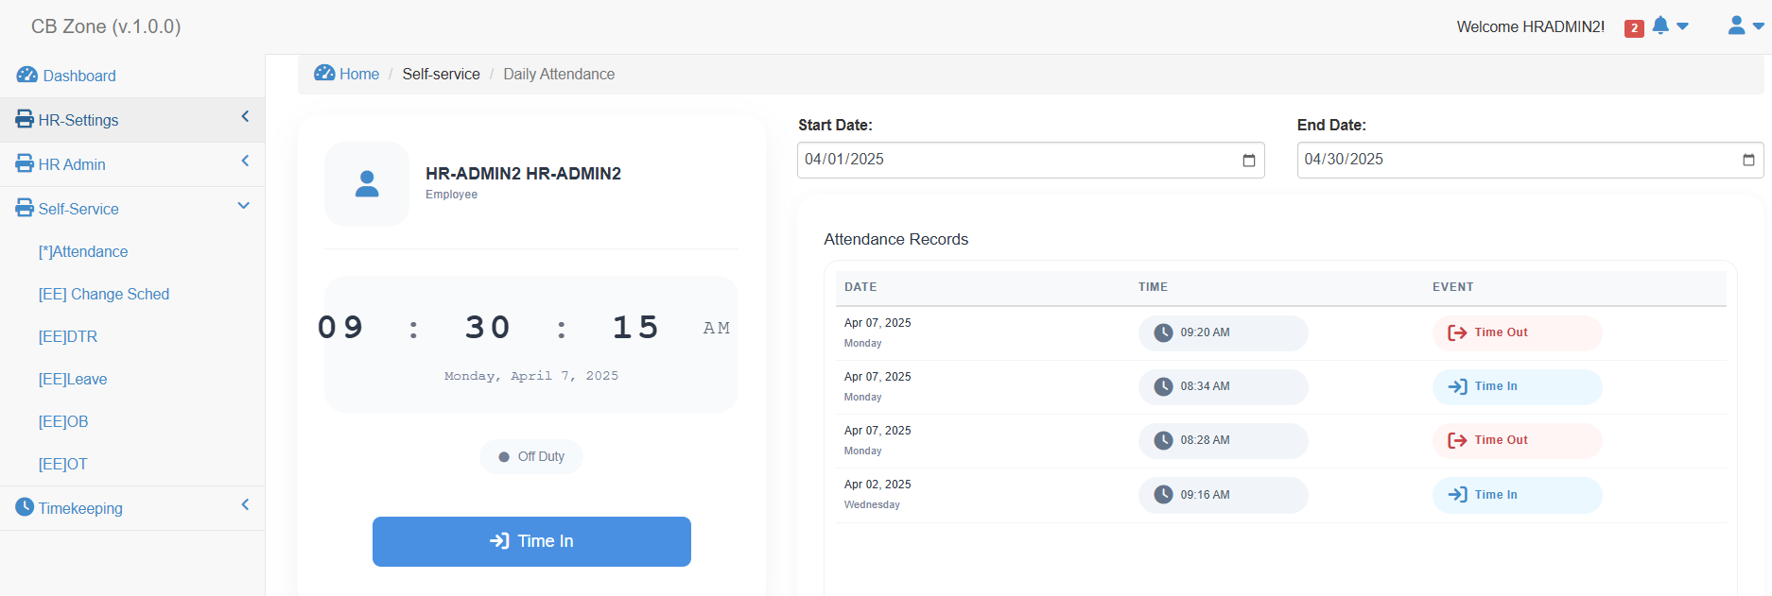
1

2

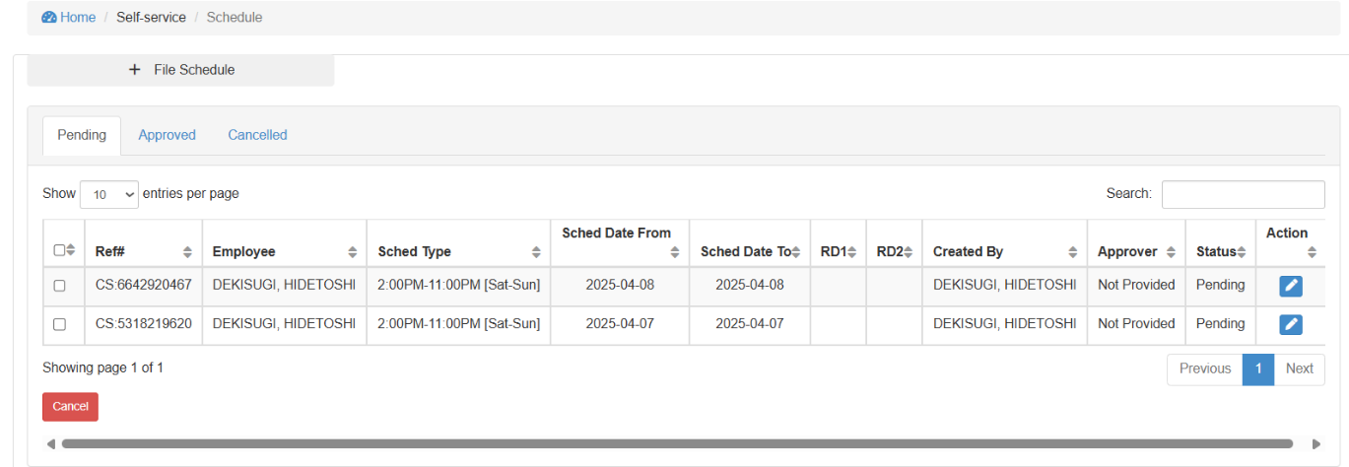
- Click [EE] Change Sched link to open Change Schedule window. The employee change schedule window will be displayed as shown on image 3.
3
Image 3. Employee Change Schedule.
- Click file schedule button to open the Change Schedule Form. The change schedule form is showed on the image 4.
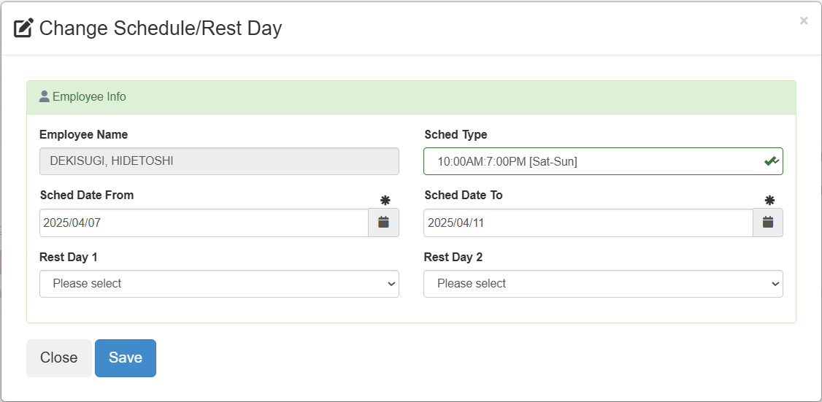

4

Image 4. Employee Change Schedule Form.
Table 1. Employee Change Schedule Form Fields.

Field | Description
Employee Name | Your name will display in this field.
Sched Type | Select the schedule type of your schedule. Schedule list is provided appendix A.)
Sched Date From | Select the start date of your selected schedule type.  Your selected schedule will start taking effect on the selected date.
Sched Date To | Select the end date of your selected schedule type.  Your selected schedule will end taking effect on the selected date.
Rest Day 1 | Select Rest Day 1 if you need to change your rest day 1  By default, each schedule type carries Rest Day 1 & Rest Day 2. Refer to appendix A.
Rest Day 2 | Select Rest Day 2 if you need to change your rest day 2.  By default, each schedule type carries Rest Day 1 & Rest Day 2. Refer to appendix A.

- Click save button to save your change schedule.
Success message will be displayed.
Note that you should not file for schedule that will overlap the other schedules.
Once created successfully, it will be sent to the assigned approver for their review and approval.
If the column approver contains “Not Provided”, it means the employee does not have approval setup.

6.2. Leave
- Navigate the leave by clicking Self-Service catalog in the navigation bar.
1

2

- Click [EE] Leave link to open leave window. The employee leave window will be displayed as shown on image 5.
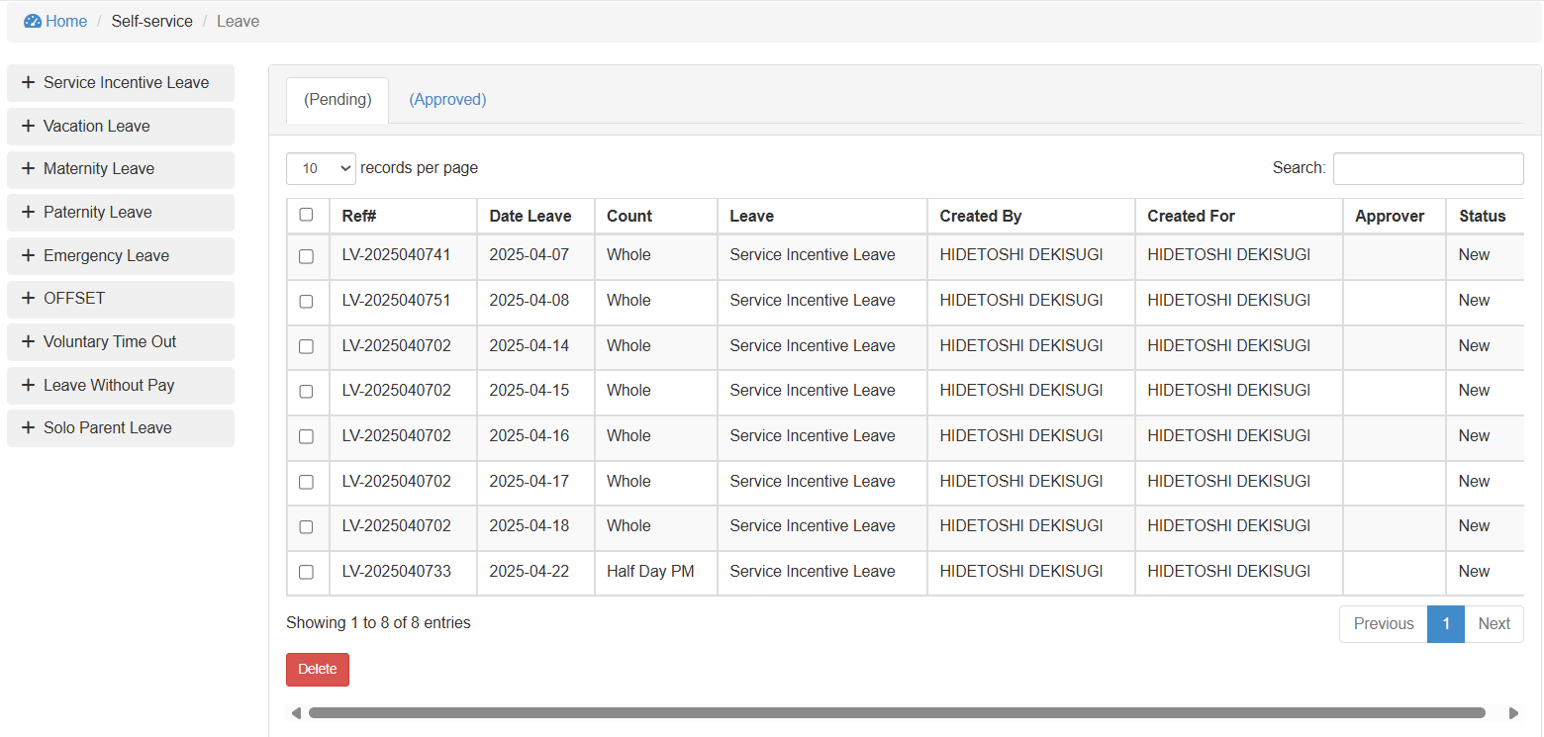
3
Image 5. Employee Leave.

- Click one button on the list of available leave. It will open a leave form as shown below.
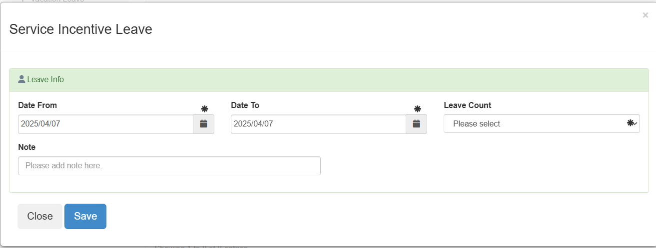

Table 2. Leave Type.

Leave | Description
Service Incentive Leave | This is the standard leave used by UHDFI that has leave credits.
Vacation Leave
Maternity Leave
Paternity Leave
Emergency Leave
OFFSET
Leave Without Pay
Solo Parent Leave | No leave credits, follow HR implementation.

- a
- sa

6.0 Self Service

